**Jaypee Institute of Information Technology**

**Database Systems & Web (15B11CI312)**

**(PLSQL)**

1. Create a function to convert distance from km to meters and centimeters.
2. Create a function to convert the given numbers into words.

Input: 123456

Output: one two three four five six

# Create a function to Reverse a number.

1. Based on CUSTOMERS table, implement following programs:

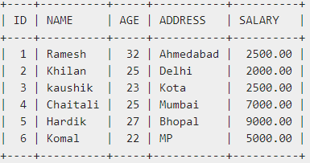

1. Program to assign name and salary of an customer where id = 5 to two scalar variables using an INTO clause and determine the number of affected rows.
2. CURSOR to select customer id, name, and address from the CUSTOMERS table where age>25 and determine the number of affected rows.
3. Create a MYSQL trigger for Product table that activates for BEFORE UPDATE event (Updating the price of product) to log the old price of a product in separate table named PriceLogs (Product Code, Price, Updated_at).